MySQL – It’s a RDBMS (Relational Database Management System)

Client – Server Software

1. Command line client (mysql command line client)
2. GUI Client (Workbench)
3. MySQL Server v8.0.x (MySQL community Server)

MySQL is a Open Source Database

It’s good choice for development & testing purpose.

Accessing mysql using command line client

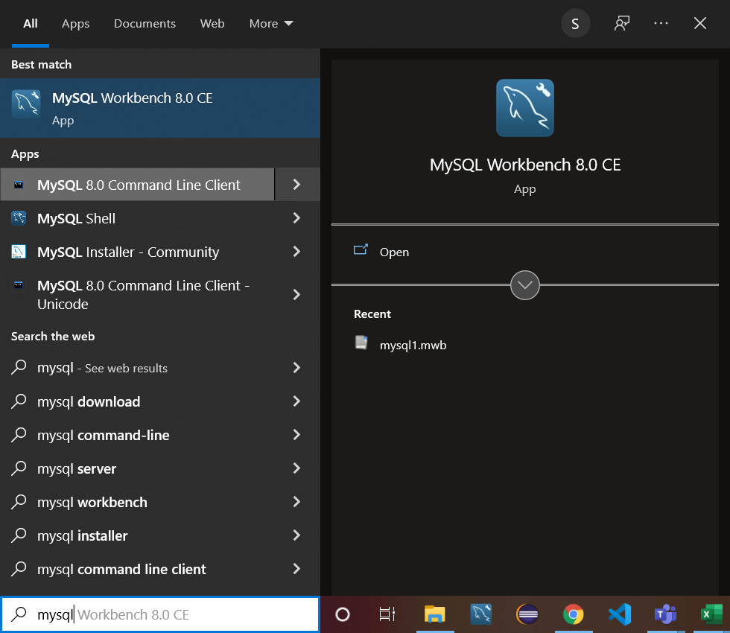

Select “MySQL Command Line Client” option.

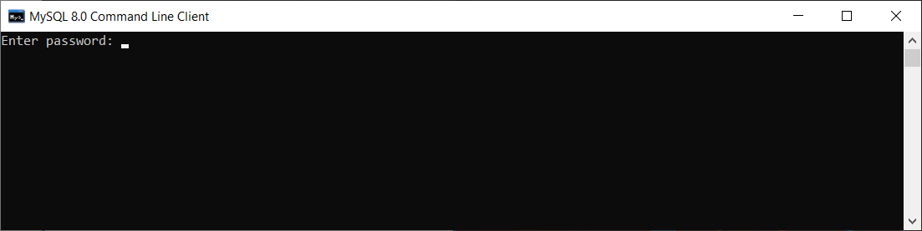

Enter the password as “root”

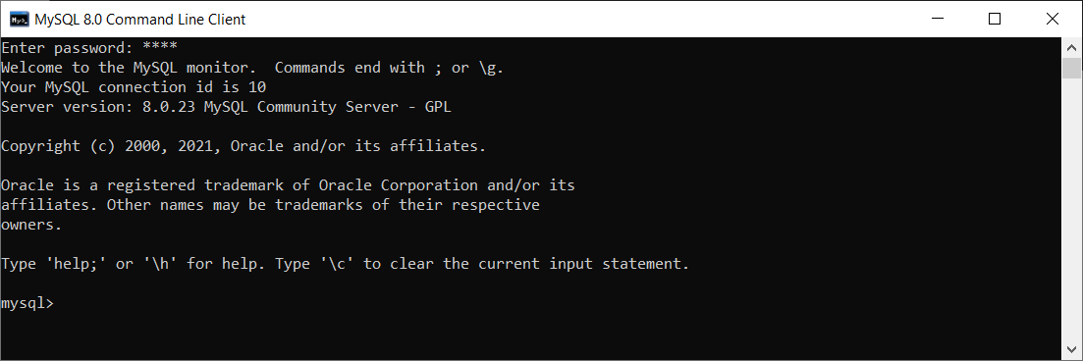

Show databases; -- This command will help you to display all the databases available.

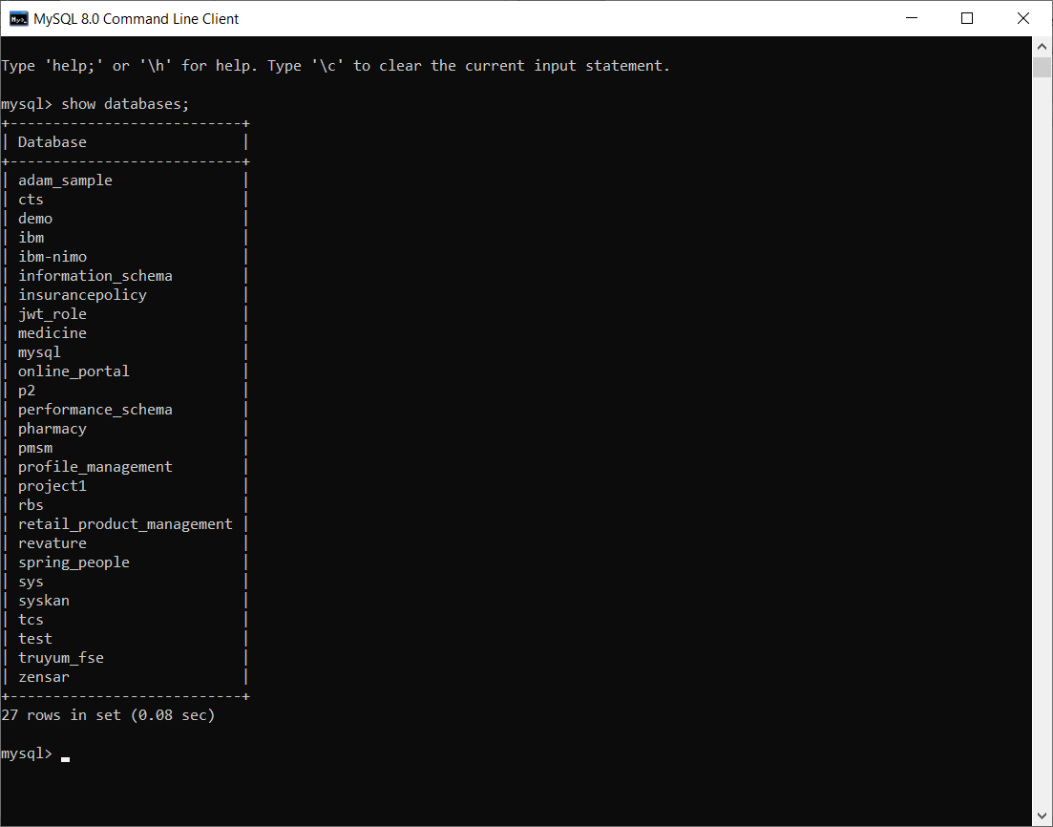

Use <db_name> -- To select any available database

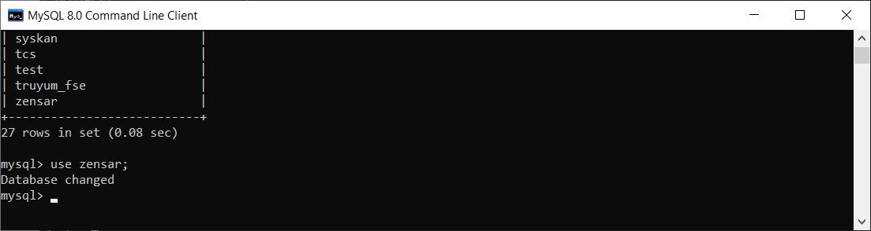

Show tables; -- To display all the available tables in that particular database/schema.

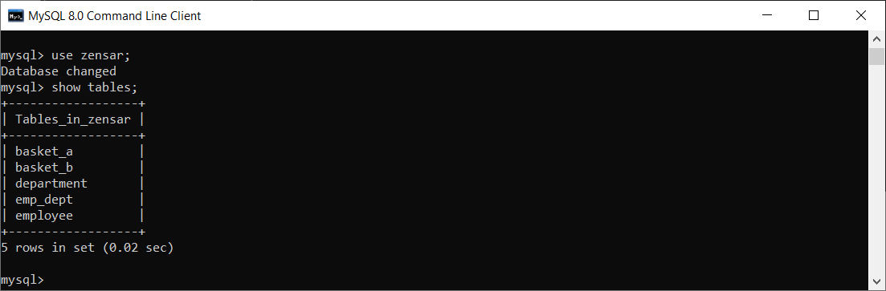

Select * from employee; -- To display the content of any table.

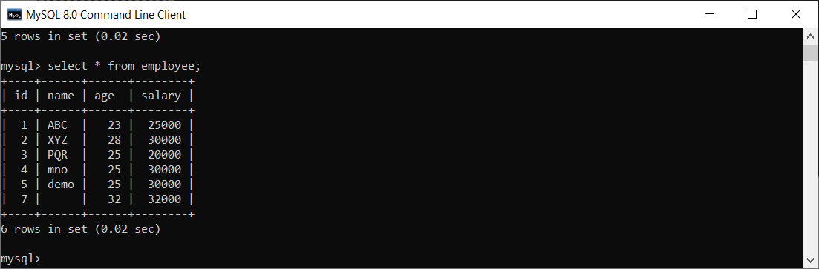

SQL – Structured Query Language. (It’s a way to interact with the database mgmt. system)

DDL – Data Definition Lang

DML – Data Manipulation Lang

DCL - Data Control Lang

TCL – Transaction Control Lang

DQL – Data Query Lang

Constraints – Constraints are nothing but rules that restrict storing different data.

1. Primary Key – Unique, Not null
2. Foreign Key
3. Unique – No Duplicates
4. Not Null – Empty values are not allowed
5. Check – Only set of pre-defined data allowed (Gender- M/F)
6. AI – Auto Increment (MySQL) – Automatically create a sequence and use it’s next value to the column.
7. ZF – Zero Fill (MySQL)

Relationship between Table

1. One to One relationship (1..1) (Primary Key – Unique value, not null) - Only one passport, One Aadhaar, One VoterId, One PAN Card, One Sun, One Earth, One Father, One Mother
2. One to Many Relationship (1..n) (Siblings, Daughters, Sons, Address, Houses, Cars, Bikes..)
3. Many to Many Relationship (m..n) (Course – Students )
4. Make Sure mysql server is running by going to task manager -> Services ->MySQL

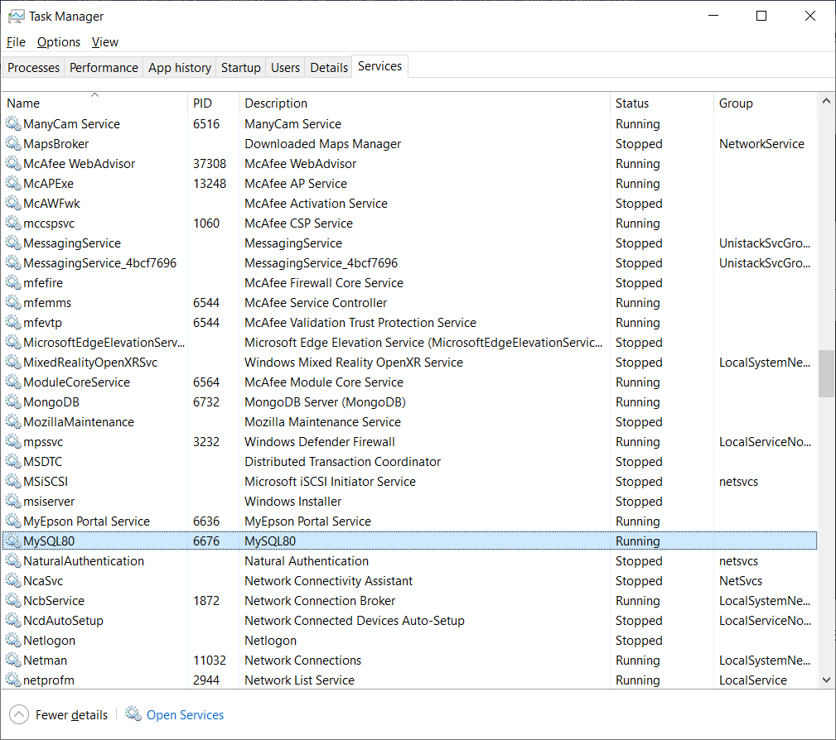

1. Log files of mysql will be available in the following location

C:\ProgramData\MySQL\MySQL Server 8.0\Data

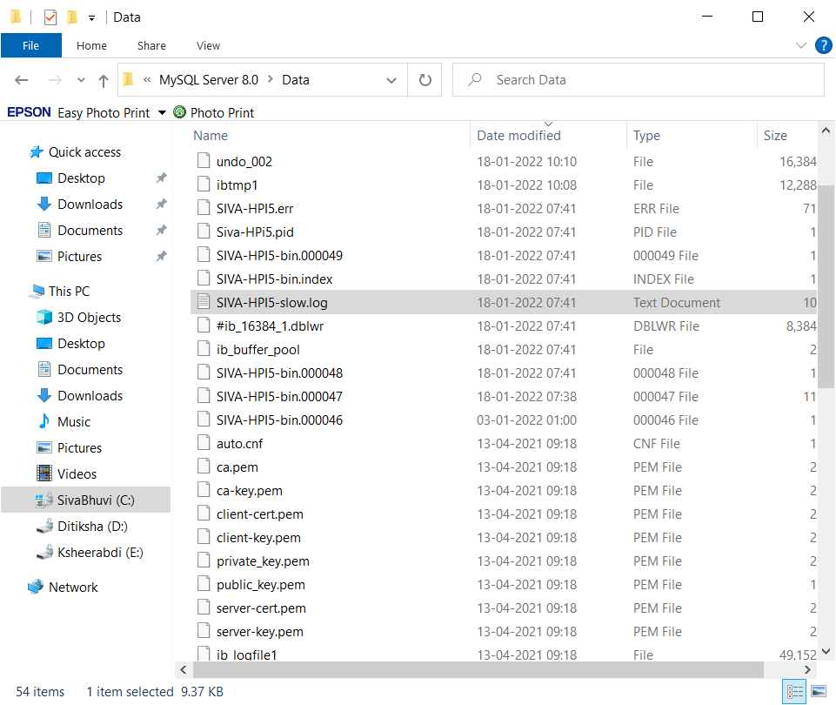

Method 2: Accessing the database using GUI (Using Workbench)

Toad /MySQL Workbench / DBeaver

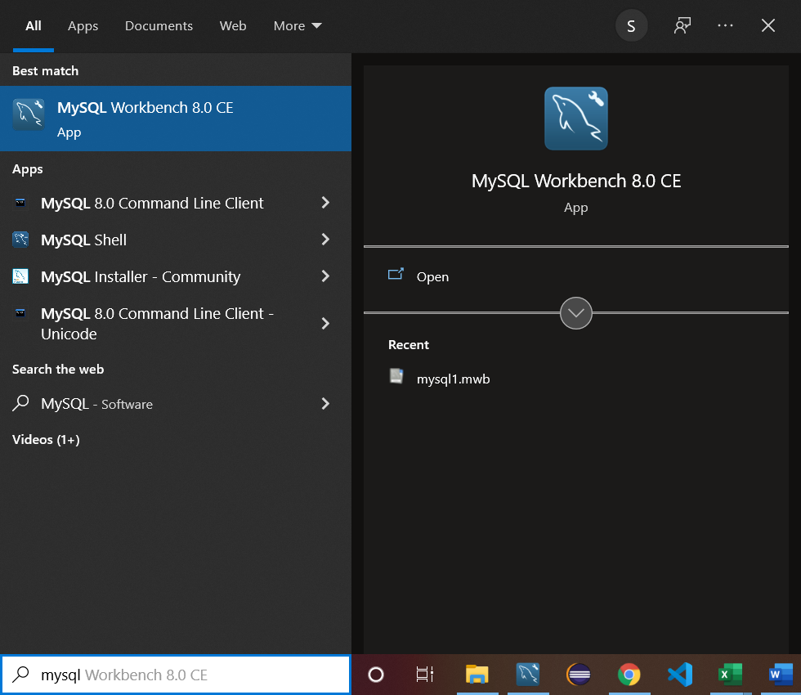

Enter the password and select the check box “Store password in vault”

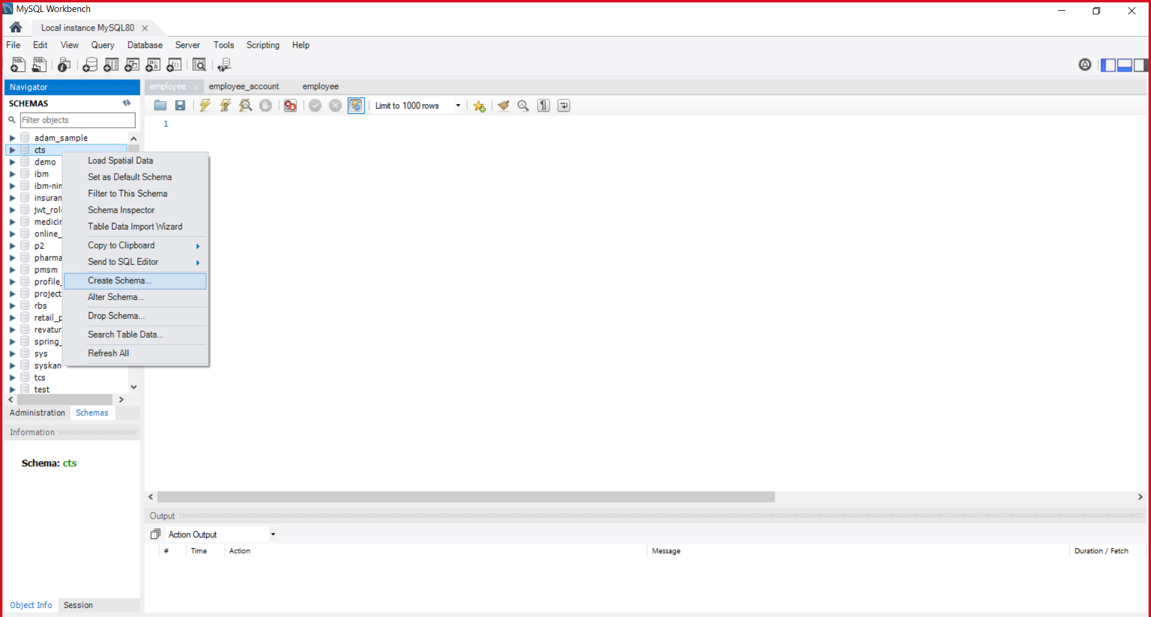

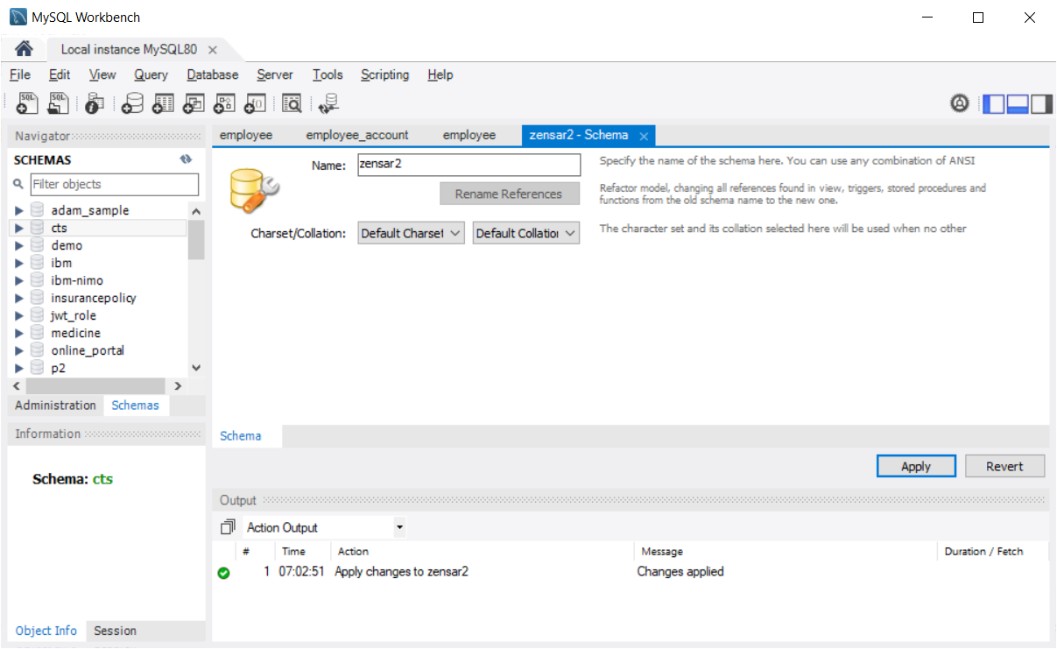

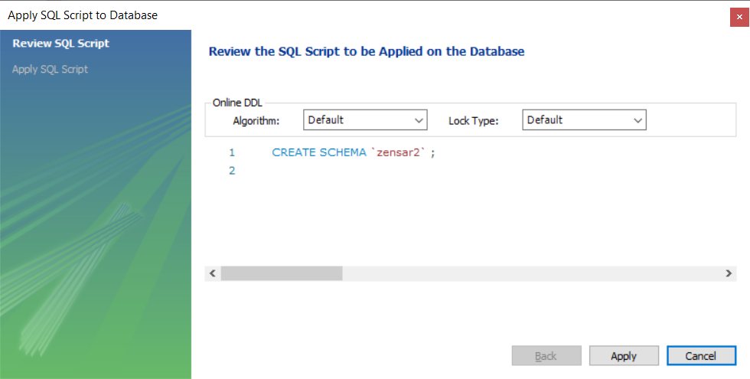

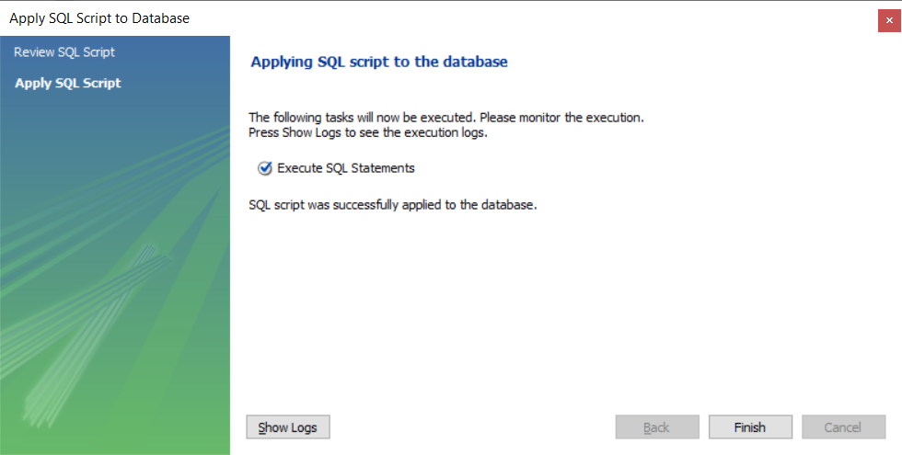

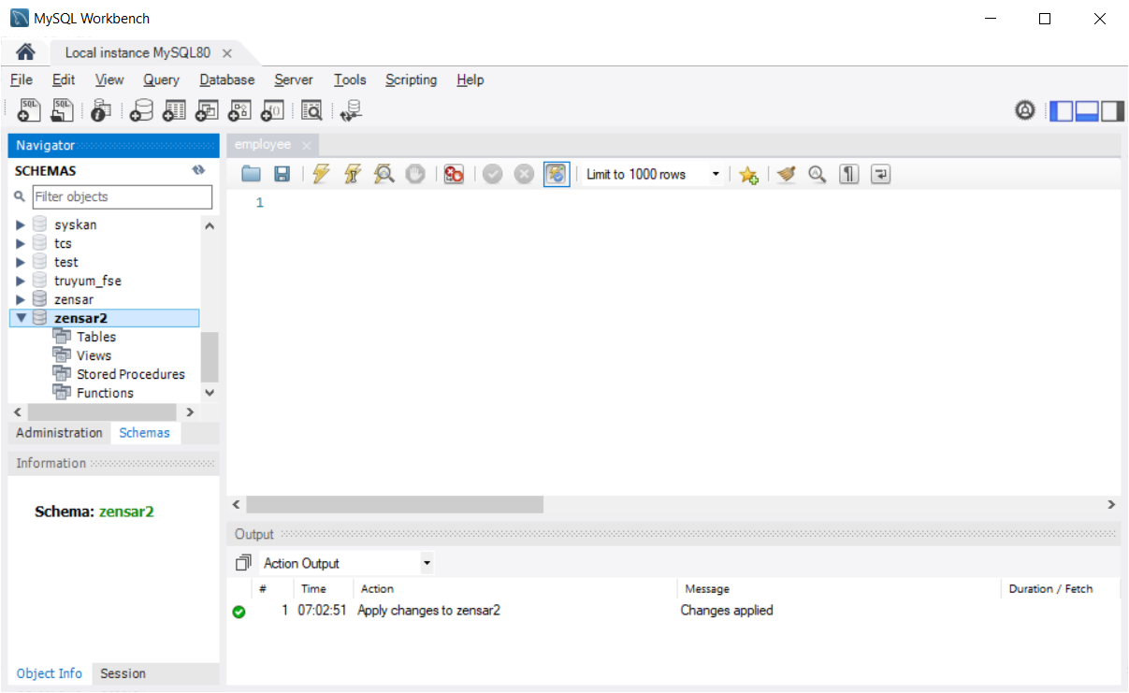

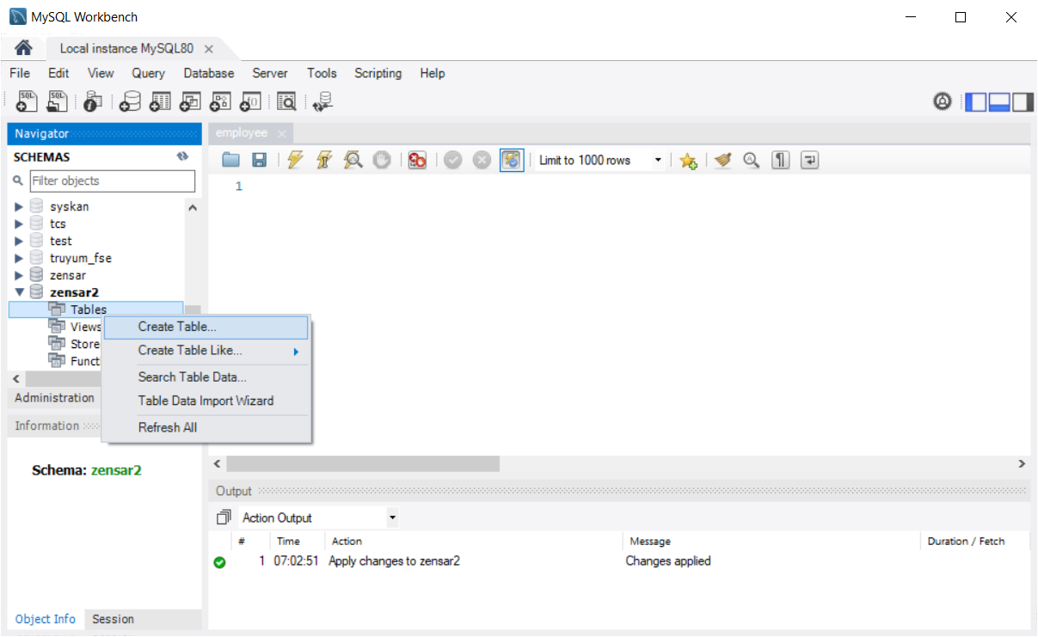

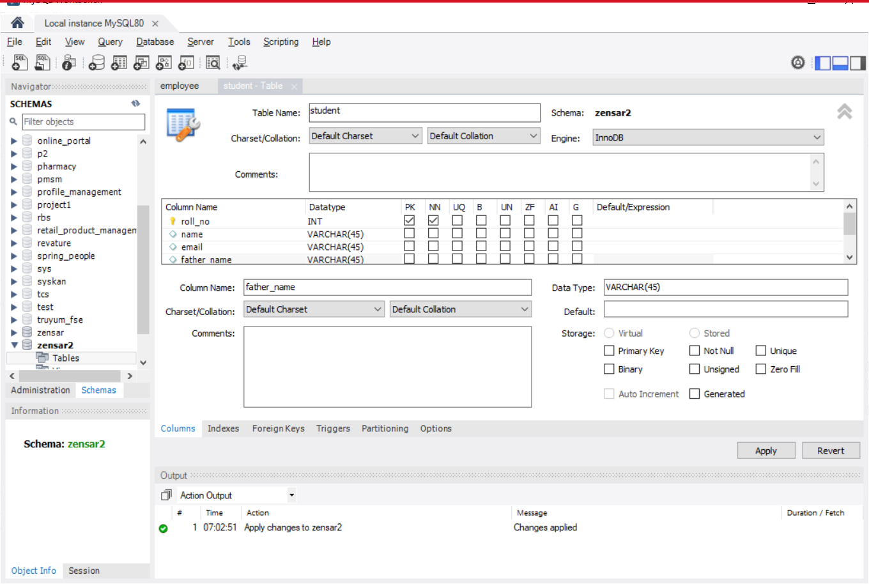

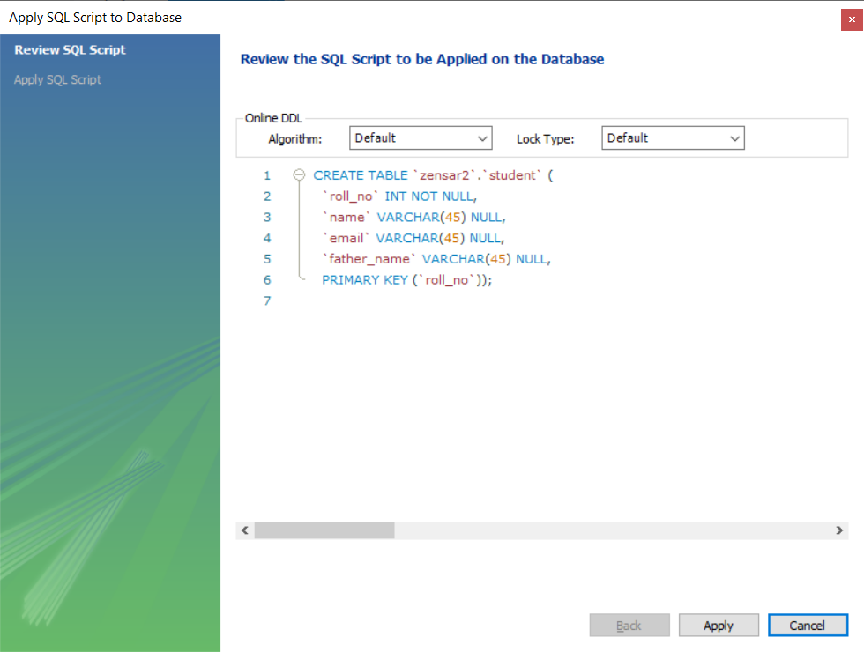

CREATE TABLE `zensar2`.`student` (

`roll_no` INT NOT NULL,

`name` VARCHAR(45) NULL,

`email` VARCHAR(45) NULL,

`father_name` VARCHAR(45) NULL,

PRIMARY KEY (`roll_no`));

INSERT INTO `zensar2`.`student` (`name`, `email`, `father_name`) VALUES ('ABC', 'abc@gmail.com', 'xyz');

INSERT INTO `zensar2`.`student` (`name`, `email`, `father_name`) VALUES ('mno', 'mno@gmail.com', 'pqr');

Method 3: Accessing the database using any Programming Lang (Java/Python/.Net/….)

In Database, everything is called as Entity (Table, View, Stored Procedure, Function, Triggers, MaterializedView, Sequence)

E-R Diagram --- Graphical representation of showing the relationship among the entities.

E- R Diagram – Entity – Relationship Diagram

Creating E-R Diagram Using MySQL Workbench